Task Scheduler Demo

1. Open the task scheduler from the windows search.

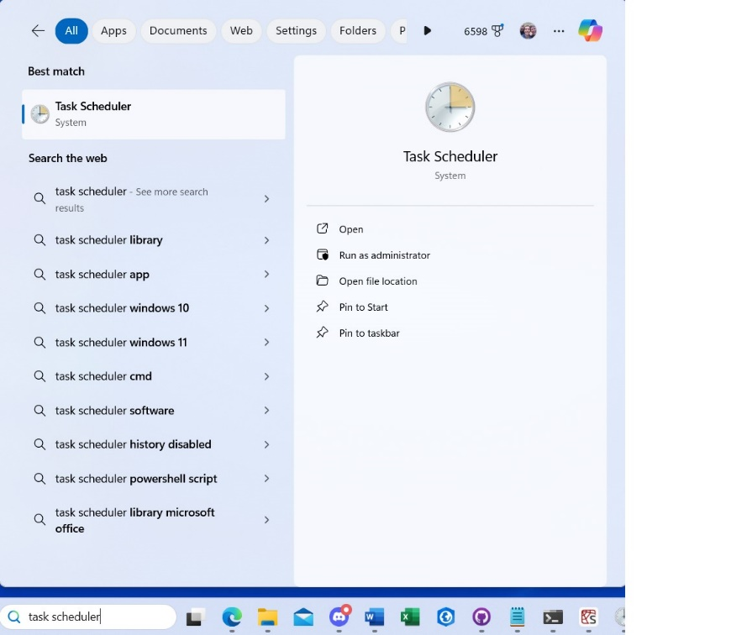

1. Click the Create Task button.

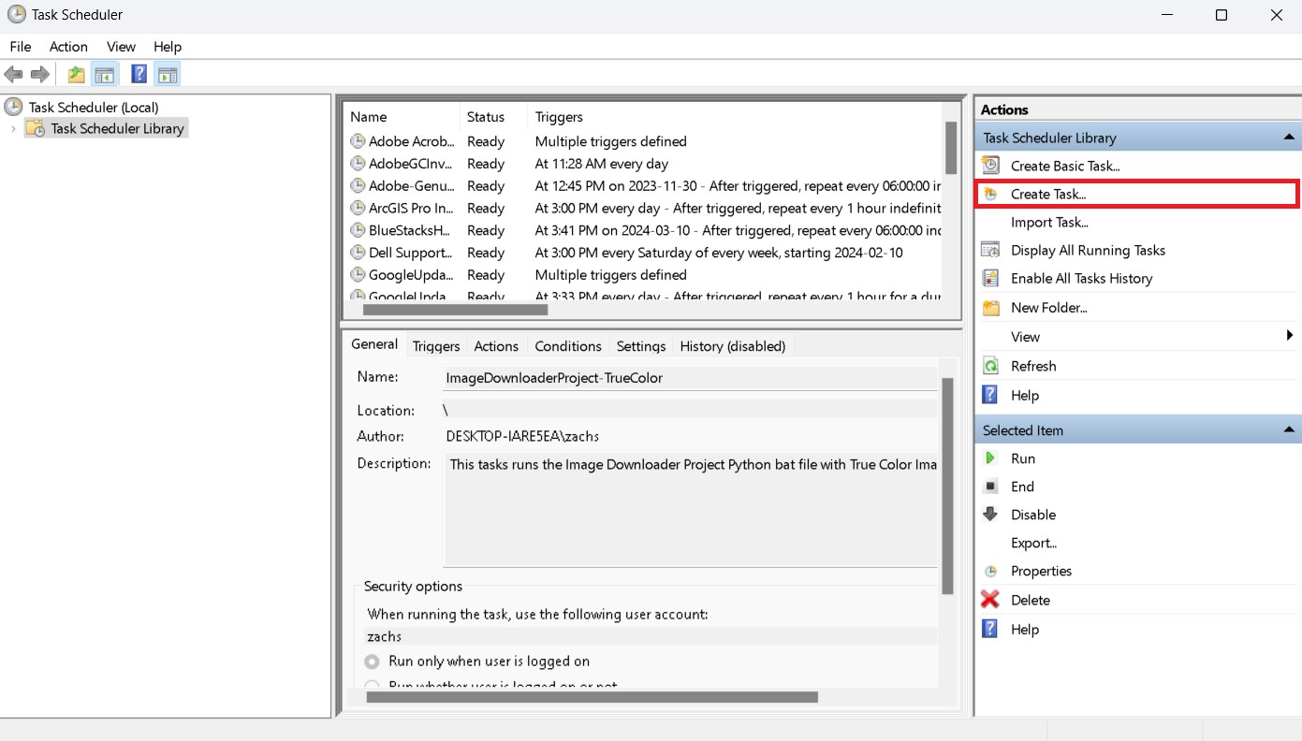

1. Name the task, and add a description and choose your security options and windows version (Windows 10 is newest)

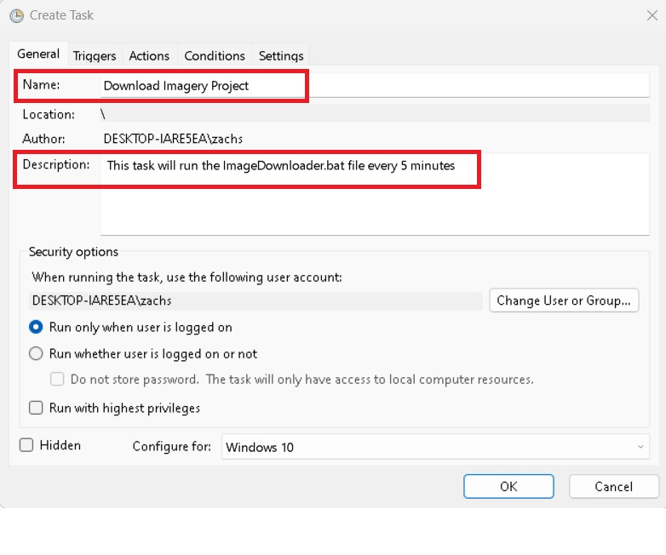

1. Add a Trigger with the new button. Choose the “Begin the task” as “On a schedule”. Select “Daily” to start at a certain time and to recur every day. In the advanced setting select “Repeat task every:” button and select every 5 minutes for the duration of 1 day. You can customize this as much as you want.

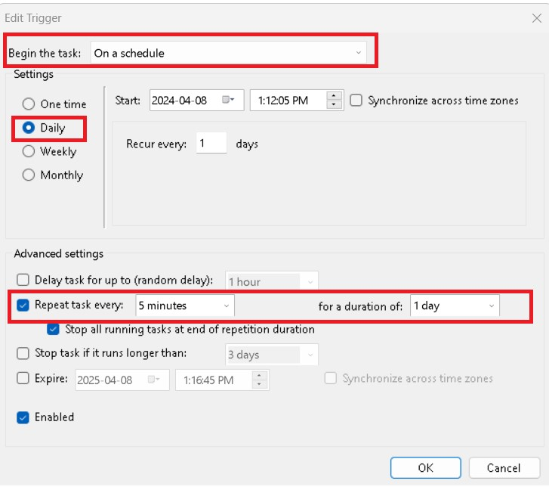

1. Go to the “Actions” tab and add a new action. Set the “Action” as “Start a program”. Set the “Program/script” with the ImageDownloader.bat file.
2. You can choose to customize any of the Conditions or Settings tab as you like.
3. Press the “Okay” button to finish creating the task.

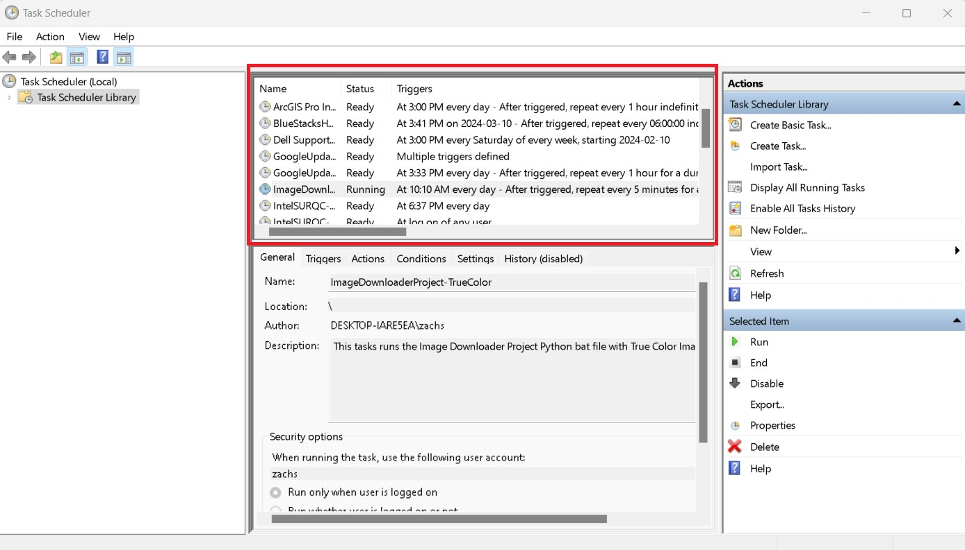

1. You can edit the task at any time by right-clicking the Task and going into its properties.
2. You can create different tasks if you would like to run False Color Images, you just need a new Parameter files Band Layers, configure file and .bat file.